This homework assignment is based on Chapter 12

**There are 2 print screens/code copy, each worth 50%**

**Project #1:** using a JFrame create the following program below. (Travel Expenses)

**#1 print screen the output with code below here.**

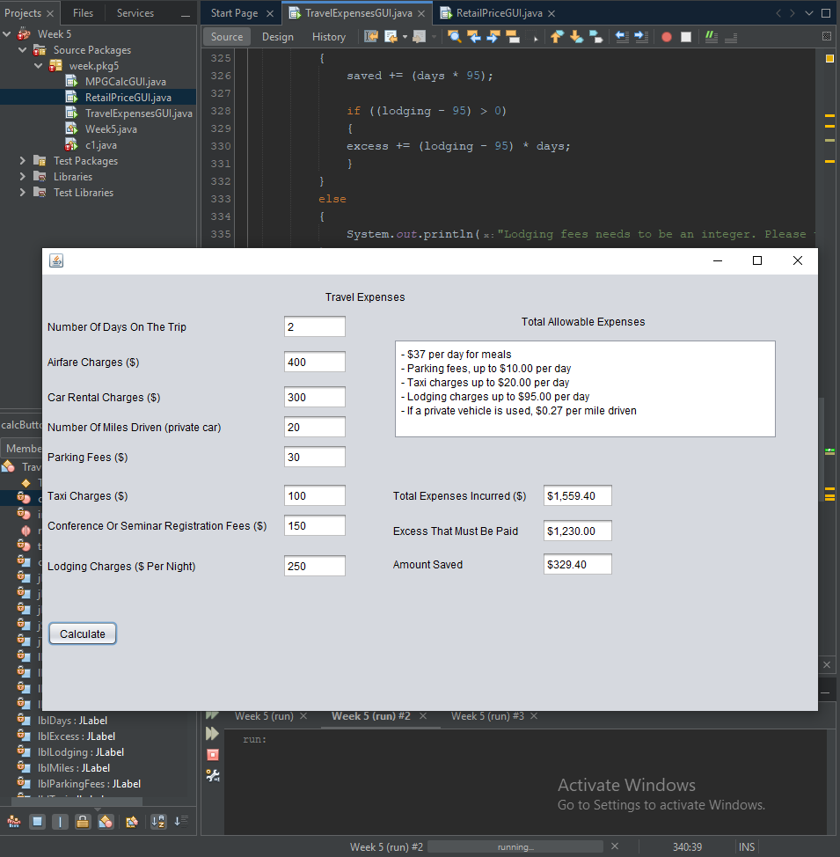

private void calcButtonActionPerformed(java.awt.event.ActionEvent evt) {

// TODO add your handling code here:

double days = Double.parseDouble(txtDays.getText());

double airfare = Double.parseDouble(txtAirfare.getText());

double rental = Double.parseDouble(txtCarRental.getText());

double miles = Double.parseDouble(txtMiles.getText());

double parking = Double.parseDouble(txtParking.getText());

double taxi = Double.parseDouble(txtTaxi.getText());

double conSem = Double.parseDouble(txtConSem.getText());

double lodging = Double.parseDouble(txtLodging.getText());

double totalExpenses;

double allowableExpenses;

double excess = 0;

double saved = 0;

if (days > 0)

{

saved += days * 37;

}

else

{

System.out.println("Number of days needs to be a positive integer. Please try again.");

}

if (miles > 0)

{

saved += miles * .27;

}

else if (miles <= 0)

{

}

else if (miles < 0)

{

System.out.println("Miles cannot be a negative number. Please try again.");

}

else

{

System.out.println("Miles needs to be a number. Please try again.");

}

if (parking < 0)

{

System.out.println("Parking charges needs to be a positive integer. Please try again.");

}

else if((parking - (days * 10)) < 0)

{

saved += parking;

}

else if ((parking - (days * 10)) >= 0)

{

saved += (days * 10);

if ((parking - (days * 10)) > 0)

{

excess += parking - (days * 10);

}

}

else

{

System.out.println("Parking charges needs to be an integer. Please try again.");

}

if (taxi < 0)

{

System.out.println("Taxi charges needs to be a positive integer. Please try again.");

}

else if((taxi - (days * 20)) < 0)

{

saved += taxi;

}

else if ((taxi - (days * 20)) >= 0)

{

saved += (days * 20);

if ((taxi - (days * 20)) > 0)

{

excess += taxi - (days * 20);

}

}

else

{

System.out.println("Taxi charges needs to be an integer. Please try again.");

}

if (lodging < 0)

{

System.out.println("Lodging fees needs to be a positive integer. Please try again.");

}

else if((lodging - 95) < 0)

{

saved += lodging * days;

}

else if ((lodging - 95) >= 0)

{

saved += (days * 95);

if ((lodging - 95) > 0)

{

excess += (lodging - 95) * days;

}

}

else

{

System.out.println("Lodging fees needs to be an integer. Please try again.");

}

totalExpenses = (days * 37) + airfare + rental + (miles * .27) + conSem + parking + taxi + (lodging * days);

excess += airfare + rental + conSem;

NumberFormat nf = NumberFormat.getCurrencyInstance();

txtTotalExpenses.setText("" + nf.format(totalExpenses));

txtExcess.setText("" + nf.format(excess));

txtSaved.setText("" + nf.format(saved));

}

**Project #2:** using a JFrame create the following program below. (Theatre Revenue)

**#2 print screen the output with code below here.**

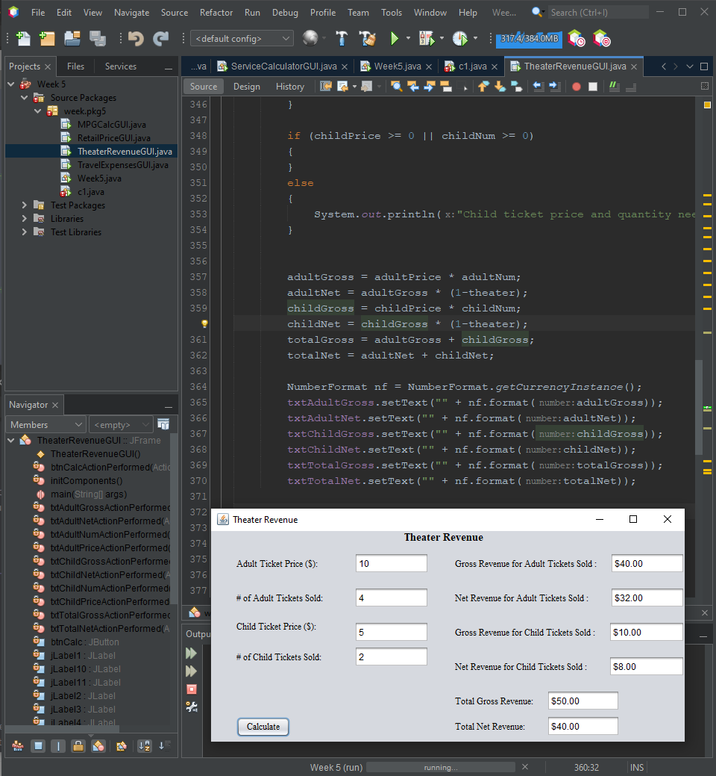

private void btnCalcActionPerformed(java.awt.event.ActionEvent evt) {

// TODO add your handling code here:

double adultPrice = Double.parseDouble(txtAdultPrice.getText());

double adultNum = Double.parseDouble(txtAdultNum.getText());

double adultGross;

double adultNet;

double childPrice = Double.parseDouble(txtChildPrice.getText());

double childNum = Double.parseDouble(txtChildNum.getText());

double childGross;

double childNet;

final double theater = .2;

double totalGross;

double totalNet;

if (adultPrice >= 0 || adultNum >= 0)

{

}

else

{

System.out.println("Adult ticket price and quantity needs to be a non negative number. Please try again.");

}

if (childPrice >= 0 || childNum >= 0)

{

}

else

{

System.out.println("Child ticket price and quantity needs to be a non negative number. Please try again.");

}

adultGross = adultPrice * adultNum;

adultNet = adultGross * (1-theater);

childGross = childPrice * childNum;

childNet = childGross * (1-theater);

totalGross = adultGross + childGross;

totalNet = adultNet + childNet;

NumberFormat nf = NumberFormat.getCurrencyInstance();

txtAdultGross.setText("" + nf.format(adultGross));

txtAdultNet.setText("" + nf.format(adultNet));

txtChildGross.setText("" + nf.format(childGross));

txtChildNet.setText("" + nf.format(childNet));

txtTotalGross.setText("" + nf.format(totalGross));

txtTotalNet.setText("" + nf.format(totalNet));

}

**Submit this document to Module 5 Homework.**